
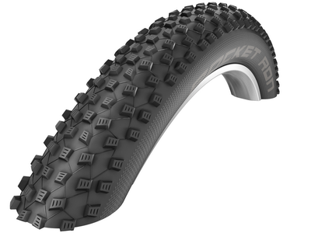
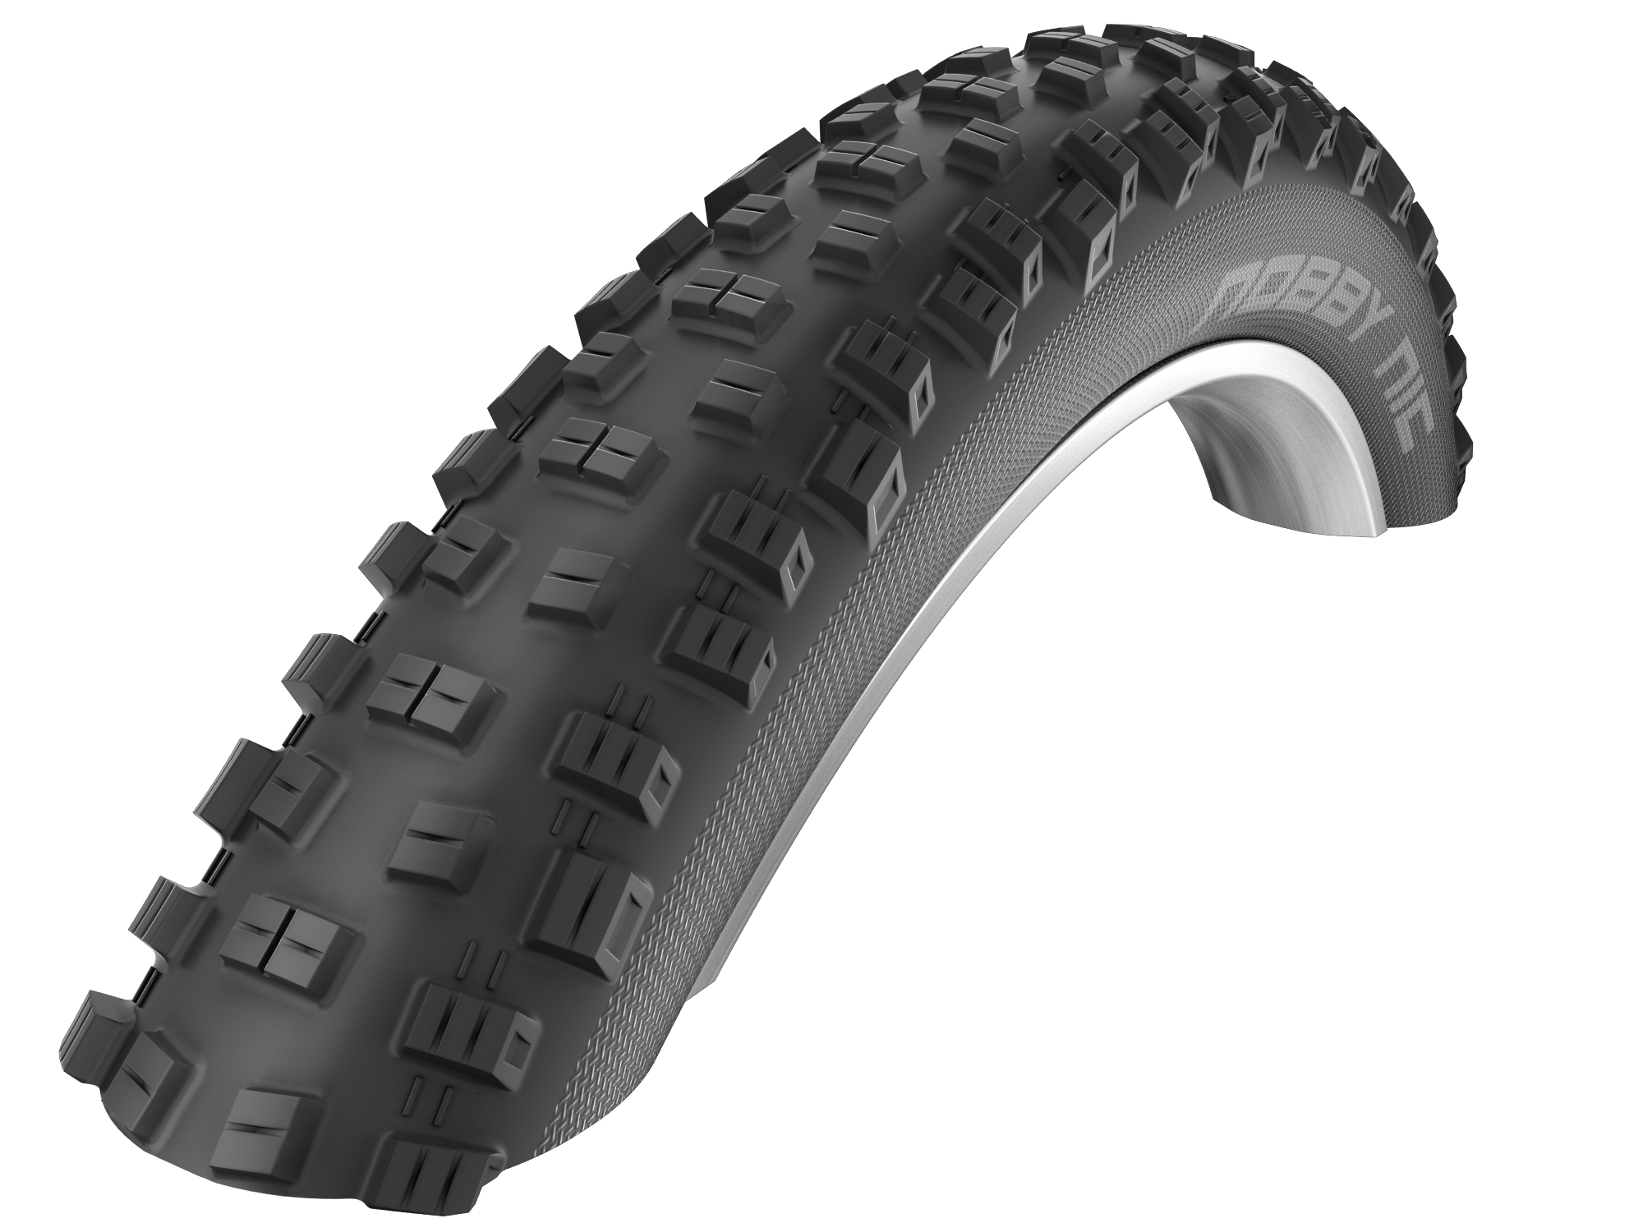

Schwalbe marketing Massive and agile at the same time: The new size 27.5+
manager Carsten Zahn. combines the advantages of MTB- and fatbike-tires.

Interview

Tire size 27.5 +: Hype or added value?

Yet another tire size? Is it really necessary? “Yes, we’re convinced it is!” states Schwalbe marketing manager Carsten Zahn and explains the advantages of the voluminous siblings in the interview.

What is behind the name 27.5+?
It refers to especially wide 27.5 inch tires. Other manufacturers call the tires 650 B+ or simply B+.

Yet another new size – why?
The fatbike trend has been a lot bigger than we expected. Of course, the bikes look cool, but their advantages only come to the fore under extreme conditions such as on loose sand, snow, or mud. For normal bikers the tire weight is a disadvantage.
But you can also see what you can do with such a great volume! The decision was therefore taken to combine the best of both worlds – the classic MTB and fatbike. The clearly bigger volume of the 27.5+ tires makes mountain biking better on all terrains and also improves the grip performance. Yet the bike also stays significantly more agile than a fatbike.

What are the specific advantages and who benefits from them?
In comparison with a fatbike, the 27.5+ bike is much more agile due to the lower wheel weight. And yet the 27.5+ also offers specific advantages compared with normal mountain bikes because the wide plus tires can be ridden with significantly less air pressure than normal MTB tires. Less pressure means more grip and control due to the considerably larger contact area. The bike has fantastic surface grip even on technically challenging terrain, making the suspension effect clearly better. These advantages also give less experienced bikers a greater sense of confidence. This also applies to technical routes that they may previously have been wary of tackling.

Will there also be 26+ and 29+ bikes and tires? How are bike manufacturers responding?
We assume that the development will focus on 27.5+. As we have frequently heard in our various conversations, many bike manufacturers are also getting geared up for this. Almost every acclaimed provider will present new 27.5+ mountain-bikes at Eurobike, many of which will have Schwalbe tires.
When it comes to additional plus sizes, there are discussions such as ‘how big is too big’ and ‘what is the best size’? The external diameter of a 27.5+ tire already amounts to 29 inches. At 29+ the bike becomes extremely large and unwieldy. And apart from fatbikes nowadays, 26 inch size wheels are almost impossible to find on the market. We therefore consider 27.5+ to be the optimum size.

What tires has Schwalbe designed in 27.5+?
Nobby Nic and Rocket Ron are available in a total of eight different versions because we want to be able to offer our customers a certain amount of choice. The 2.8 inch width gives experienced mountain bikers a sporty and agile biking experience. Those who want to use all the positive effects of the high volume tires should use the 3.0.
Nobby Nic is our most popular and varied tire, having been grip- and performance-optimized, where its profile has been adjusted to the broader tire width.
In contrast we have trimmed down the Rocket Ron to a low weight and low rolling resistance. It has relatively small studs in the tread center. The fat plus version features even more of these – which means that it runs very lightly for such a fat tire, and weighing just 680 grams, it is very light.

What is your personal impression when riding 27.5+?
I am a big fan! These tires offer performance, safety and cycling fun. I wasn't so enthused by the classic fatbikes, but I've been really taken with the 27.5+! All things considered, 27.5+ tires and bikes offer advantages for all current mountain bikers – and for aspiring mountain bikers as well.

Schwalbe Tires in 27.5+ Plus will be available from Spring 2016 in the specialized trade.

This press release with photos and Graphics can be downloaded from: www.schwalbe.com/en/presse.html

SCHWALBE - Ralf Bohle GmbH  Doris Klytta
Otto-Hahn-Straße 1  51580 Reichshof-Wehnrath
Telefon: +49 2265 109-57  Fax: +49 2265 7022
d.klytta@schwalbe.com  www.schwalbe.com

